BIKE READY Guide

Learning from Sandy:
Bicyclers, get organized for ongoing emergencies

Framing cyclists’ response in the aftermath of Superstorm Sandy, this film has become a springboard for local preparedness. In this Guide, we introduce four topics that will help you get ready. Be #BikeReady!

Organizing bicyclists for emergencies

To spark local conversations and preparedness, we used a real world example from New York City. We reviewed and re-edited video footage of several post-Sandy bicycle relief rides that illustrate the benefits of organizing bicyclists for emergency response and resiliency.

Scenes from the flooded streets of coastal neighborhoods from Manhattan’s Lower East Side to the devastated Rockaways in Queens in Fall 2012 are featured in the 4-minute video, along with tips for organizing and equipping cyclists and community members for rapid response. We made this Guide to use as reference, together with the film. Watch & discuss with your bike buddies!
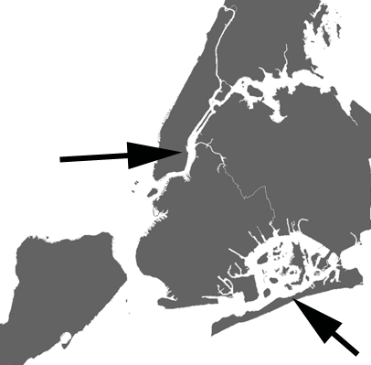
Get organized! This Video and Guide will help you create:
1. List of bike groups & helpful people
2. Ways to communicate when disaster strikes
3. List of available resources, such as bike trailers, etc.
4. Bike repair kit for you and your emergency center

Share your tips & best practices at #BikeReady on Twitter. Contact us at apple@greenmap.org.

Thank you for taking the lead – someday, it may make a big difference to your community! You can get active anytime and review/update when you hear a huge storm is predicted. Some cities have annual preparedness days, and you can bring the Bike Ready video and guide. Of course, you can add other resources you have found handy to your Bike Ready kit.

http://GreenMap.org/bikeready

Created in Spring 2016 by Green Map System, this project had the benefit of working with the original videographers of the Fossil Fuel Relief Ride and Sandy Hits Avenue C – both of which can be seen at Peter Shapiro’s website, petershapiro.com. He and Barbara Ross filmed the bicycle relief rides over several days in Fall 2012, with volunteers from the bike group Time’s Up and members of Occupy Sandy Relief, which was the first to be organized to reach vulnerable communities. Tony Rodriguez provided Lower East Side footage and in the film, you hear Keegan Stephan, Monica Hunken, Carl Love, Betsy, Peter Shapiro, Barbara Ross and Wendy Brawer, who produced this project with the help of Roy Interstitial and a seed grant from LES Ready.
This work is licensed under a Creative Commons Attribution-ShareAlike 4.0 International License.
1. List of bike groups and helpful people

As you start to organize, you will be developing a small core group that will help keep the lists handy and be Bike Ready when the time comes.

Use this List to collect the names and contact information of local bike groups and interested bicyclers.

Many different skills are useful, and being able to ride long distances may not be needed. Walking a laden-down bike a few blocks can be very helpful, too.

Your list should include multiple ways of reaching people because phones or the internet may not work when you are mobilizing to respond to a crisis. Designate 2-3 key people who will have a copy of the list and can help mobilize. Create space to identify these key people, special skills (first aid, bike mechanic, etc.) and what tools they have (bike trailer, bike repair stand, etc.).

You can also create an online survey (free to use: Google Doc or Survey Monkey) or use a spreadsheet to organize the information.

If you collect this information on paper, it’s a good idea to type up, then verify that it is correct before you share it with trusted bike group members.

You can give your local Emergency Center a short list of key groups and people to contact who can notify the others.

Name Bike Group Address Skills Tools *Note

Phone Alt Phone email hashtag Celly other

* Notes can indicate that this is a key person, they know first aid, a second language, etc.
Consider updating the list every so often.

If there’s an active Citizens Emergency Response Team (CERT), or other kinds of preparedness groups or agencies that you work with, discuss your Bike Ready efforts with them.

2. Ways to communicate when disaster strikes

Though it may seem redundant, it’s a great idea to have multiple ways to reach people. There are many options: Email, text message, phone call - Skype, Whatsapp, Messenger, and whatever is popular in your community. It’s a good idea to practice if the system is new to some people.

On Twitter, you can use a hashtag like #BikeReady and include @YourBikeGroup @YourCity along with your location, meeting time and date, and other information so people can get together, pitch in, get help, etc. Keep it simple and clear.

You can set your group up on a service like Celly. As seen at https://cel.ly/ it’s a free app that will notify each of your group members in different ways, including SMS. It has several functions. Of course, use whatever works best in your community – the goal is easier communications.

What is a ‘phone tree’? It’s a simple phone list made and distributed in advance. Each person calls 5 people. These people each call 5 people, who each call 5 people, and so on. Very quickly, a large number of people are contacted. This works great with landlines when the power is down, too.
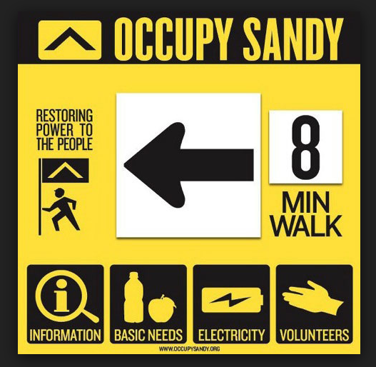

Signage also works! Include specific details, including date and time, to be most effective. They can announce a meeting place, bike repair sessions, when the energy bike will be giving charges, etc. Occupy Sandy Relief made eye-catching signs and relied on symbols to include people with different languages. Including a familiar group name on the signage builds trust.

3 List of available resources, such as bike trailers, cargo bikes, etc.

You can collect this information more gradually. You can use a survey or your phone’s note pad to keep a running list. If you have an office or regular meeting space, you can even keep this list on a bulletin board.

People may have bike trailers, bungees (tie down straps), tools, cargo bikes, kiddie carts, energy bike, a bike rack for a car, a bike repair stand, etc. Ask around. You can transport cargo using almost anything with wheels. While you are at it, note related resources such as a solar charger, good places to set up for repairs, etc.

Collect the locations of bike stores that may want to pitch in or provide a staff member to volunteer, etc. Other businesses may be interested in being on the list too.

Talk to your city’s office of emergency response. Find out if bike evacuation routes are in their emergency plan (and if not, lobby for it!). Journalists, mapmakers, planners and community organizers will find value in this effort.

Collect other local emergency information. For example, in NYC, people who are already members can use the NYC Bikeshare system even when the electricity grid is down.

If you are lucky enough to have access to an energy bike, we advise that you practice working with it in advance. Consider getting some spare parts, and learn how to optimize charging (for example, iPhones charge faster in ‘Airplane mode’). If you want to build one, there are many videos and other instructions online.

And do check out a very detailed list of support resources in advance at http://occupysandy.net/resources/ - all sorts of issues appear here. This website is quite useful! It’s all about mutual aid, not charity!
4 Bike repair kit: one for you and one for your emergency center

Contents of Basic Bike Repair Kit – ideal for fixing flats and minor adjustments
Tire Levers
Patch Kits (several)
Floor Pump
Hand Pump (small, cheap)
Duct Tape
Allen Wrench Set (metric)
Adjustable Wrench 8 inch
Adjustable Wrench 6 inch
Vice Grip (6 inch)
Chain Lube
Grease

Supplementary:
Combination Wrench/Nut Driver (8-9-10 mm)
Needle Nose Pliers
Slip Joint Pliers
Screwdrivers (flat and Phillips)
Channel Locks
Hammer
First Aid & clean up supplies

Mark your tools. Add tape (electrical works well, wrapped around with a little tail) that has your group name and contact, this will help your tool kit last longer.

Recommended for your personal bike repair kit: spare tubes that fit your own bike. Bike lights and extra batteries, possibly even a reflective vest. Consider getting a headlamp and a supply of bungees (tie down straps) and work gloves.

Decide if it’s better to make a couple of kits, in case one becomes inaccessible when the emergency strikes. You can ‘crowd-fund’ to make them (try IOBY.org). Or, you can ask for a tool donation from a local bike shop, too.

Organize the kit(s) and pack everything into a sturdy, waterproof box(s). Talk with your Bike Ready friends about the best place to keep it, such as an emergency center, bike group headquarters, or other community gathering place.

Bike Ready Lower East Side created three kits using the list above, spending about $100 per kit. We placed them in three neighborhood emergency centers. These locations were shared with the Bike Ready group, and the neighborhood response coalition, LES Ready. We expect to use them during storm-related or emergency outages, transit strikes, or even during times of stress when people need mutual aid to rebuild their sense of community.

Created by Green Map System, May 2016. Contact us at +1 212 674 1631 or apple@greenmap.org or tweet at #BikeReady. Watch for updates at GreenMap.org/bikeready

