Mobile Site Collector Workshop Guide
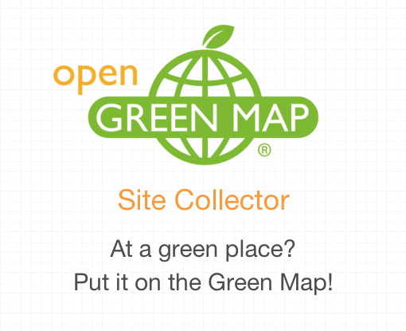

Based on the first Green Map Mobile Site Collector Workshop
around the United Nations District in July 2014 ( blog below), our 2014 summer interns, Benji Schulman of Johannesburg Green Map and Samantha Riccio of New York, developed (and are quoted in) this guide. It will help your event sparkle!

Tips for Workshop
- The new Green Map Mobile Site Collector is designed to engage! Try it and see if it ignites new participation and excitement in your community.
- Make sure your map is public, not ‘private’ a day before workshop or it won’t appear on the Collector’s list of maps!
- Make sure you can get online at the workshop venue.
- Have a paper map or buddy up to include people without a mobile device.
- Take photos or videos during the event and tweet with #mobiGreenMap.
- As Mapmakers import each site (from Import-Export Tab’s top link), it appears on the map, and on the Map Dashboard. Like all the other sites, any detail, location or icons can be edited.
- Promote the event with ‘Map it Fast’ and a short clear description. Offer food and drinks as incentive for the groups to return after mapping.

The invitation for the 3-hour UN District workshop is attached at the end. “Having a local community board member there was extremely helpful.” Is there anyone you’d especially like to take part? Be sure to invite them personally. We also added the handout and blog.

You can add a Collector training to many types of workshops. You may find it easier to work with than OpenGreenMap’s Add a Site form from your desktop on an everyday basis!

Schedule for workshop
- Introduction Icebreaker
“We asked for participants to share their name, organization, home country and ‘What is the greenest thing you have done today?’
- Introduce the local Green Map project, the icons and the global network (“We used the slideshow here” (more presentation resources to come))
- Introduce the Mobile Site Collector (we suggest viewing the video and practicing first).
• Project the Mobile Site Collector on a wall and gather everyone around--make sure no one is using their mobile yet! You can narrow your browser window on the desktop to make the Collector appear as it does on the phone (it’s called a ‘responsive website’ because it automatically responds to the device it’s on and changes shape).
• What kinds of sites should be mapped? What do they want mapped? What sites do we already know about and which areas should be checked more carefully?
• Show how to use the Collector - get someone to suggest an example site and walk them through the process of adding it.
• Once the Collector is generally understood, let participants try it themselves while you walk around, seeing if anyone needs guidance or has questions.
• Return to the question of what the group wants mapped and plan where to go to find these resources nearby.
• Split into different groups of 3-4 people. Discuss with each group where they are going and what they are mapping before going in the field to ensure relevancy. Make sure the groups don’t stay out too long so they can share findings when they return. “We gave them 30 minutes and encouraged them collect 3 sites (one per person in each group)”.
- Take everyone outside. Shoot a group photo, and perhaps, a few shots of the groups out looking for sites. Participants may want to click Refresh GPS on the Add Site page if they are going some distance from the workshop location
- The group returns for discussion and snacks. “While they were out, we imported most of the sites they collected, leaving just a couple to show the group how that step was done.” Show participants how they import it into their Open Green Map. Each participant should receive an automatic email confirming their site is on the map (you’ll receive a duplicate, so you can reach out later and invite them to join your map team or thank them).
  - Once all sites are added, project the map they created.
    - Click on their sites to discuss their descriptions and photos.
  - Discuss what this map shows about the community. What else could have been mapped? What would show more of the community’s strengths and weaknesses?
If people want to make comments or suggestions about the Collector, encourage them to use the survey (or add them there yourself) – http://bit.ly/GMSCsurvey

  - Make a plan for continuing the project, for example by asking each person to add at least 3 more sites in the next week. Plan a gathering that involves more participants in mapping another theme or area.
  - Write a blog or tweet about your workshop and plans. Add the #mobiGreenMap hashtag so we can share your news!
  - Now that you know how to engage participation with the Collector, we hope it will lead to more effective Green Maps that address more issues and opportunities in your community!

Created in August 2014, we hope this basic guide has been useful!
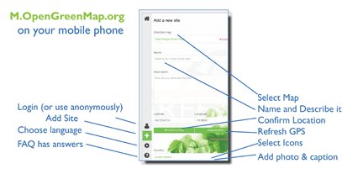
You can help improve it
– contact us at info@greenmap.org!

Thank you from Wendy, Samantha and Benji

PS - find this image below, too!
Here is the invitation:

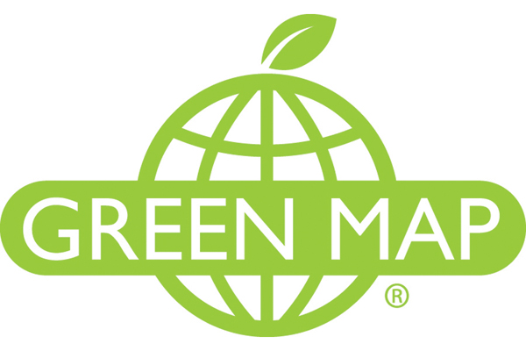
Help Make the UN District Green Map

Introduction
The district around the UN has a reputation for being one of the more affluent parts of New York City. It sits in the boundaries of Community Board 6 of Manhattan which includes the area between 14th and 59th street and stretches from Lexington to the East River. For many of us who work at the UN, the area is considered the centre of the Manhattan Island, with its many international affairs offices, business and historic activities. However, there are still challenges to its urban character. The district has some unique assets, but many are overlooked by residents and visitors who notice instead inadequate shelter for the homeless, under-resourced education facilities, serious traffic congestation, pedestrian safety threats (from bikes and cars), East River water quality concerns and a minimum of public open space.
What’s happening in the neighbourhood?
Recently Mayor De Blasio has embarked on a new zoning and building plan for Midtown which will likely have an impact on the UN district. Community Board 6 has an excellent record of liaison work with the city administration resulting in innovative solutions proposed to address the area’s challenges. This increased attention offers an opportunity to provide new visions and perspectives through the making of a Green Map that can positively impact the area’s future and increase the interaction of the UN with the surrounding community.
What is a Green Map?
Green Map System is a tool developed in the early 1990’s here in New York that allows communities to highlight and assess local and environmental assets that exist in their area. Now, local Green Mapmakers in 65 countries chart engaging, universal icons on an interactive mapping platform to point out green living, cultural, natural and other sites that are important to the community. This re-imagination of the urban space helps to pivot perceptions towards bottom-up potential for local use. The UN District Green Map will help catalogue existing community assets and show planning authorities (including inside the UN) how those assets can be used more effectively and lead toward creative ways to assist in making the area ‘greener’ and more sustainable.
How can you help make the UN District Green Map?
To create the UN District Green Map we need to find out what’s actually out there, and the best way to really know is to “hit the tarmac.” Therefore we will host a walkabout (with lunch) to get (and then communicate) a full sense of the neighbourhood. As part of the walkabout we will be using the state-of-the-art Green Map geo-collector app and mapping platform to confirm knowledge of pre-existing sites, add new ones and document the entire process with photos and text. Help make NYC greener! Join us!
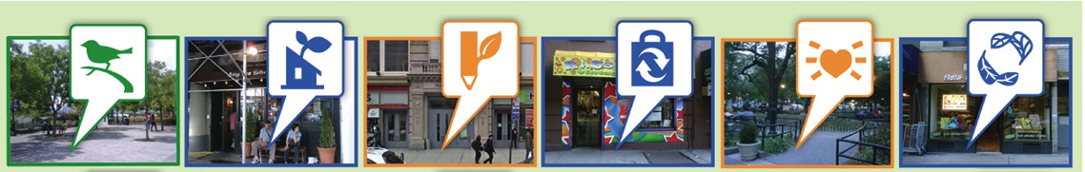
To attend please RSVP for security (and food) purposes to Benji Shulman egoligreen@gmail.com. Date: 17 July 2014 Time: 15-00 to 17-00 Where: Global Action to Prevent War Office 866 UN Plaza, Suite 4050 (1st Ave and 48th St). Don’t forget your ID and your smartphone or tablet and weather appropriate clothing!

Here is the Handout:
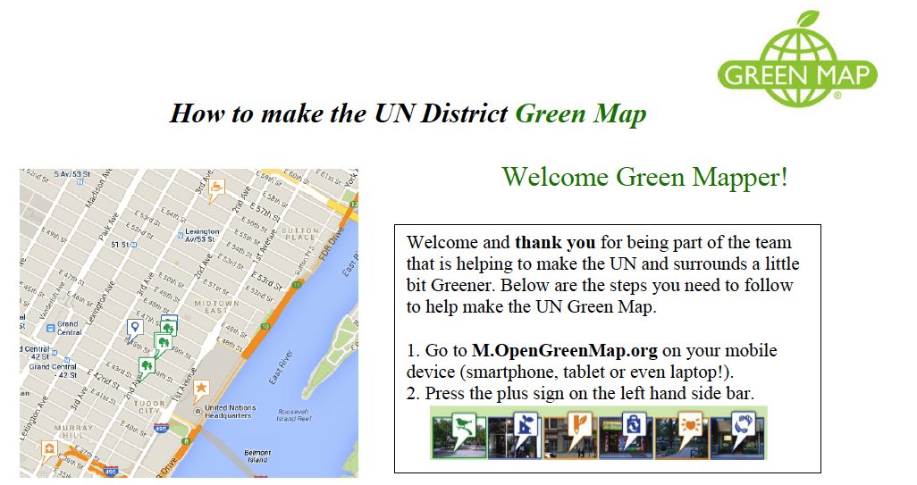
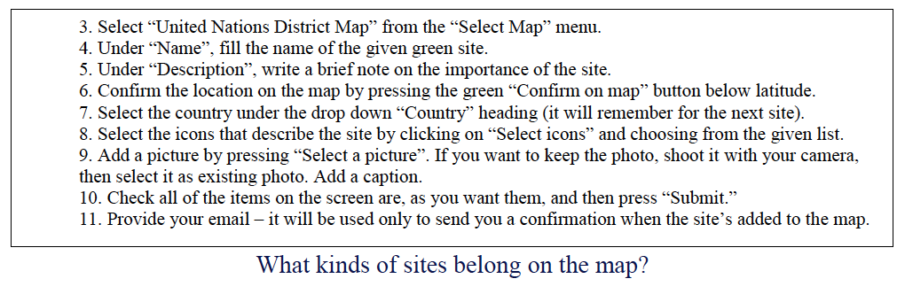
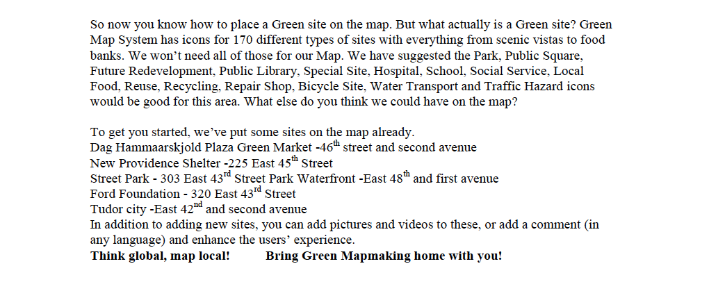

- Here is the Blog!
    - In July, we took part in organizing a workshop at the United Nations that introduced Green Map’s new Mobile Site Collector to participants from 7 countries - explore the map we made atOpenGreenMap.org/UNdistrict-nyc!
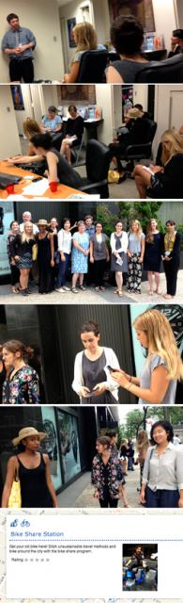

Organized by summer interns Benji Shulman and Samantha Riccio, it was hosted at the head office of Global Action to Prevent War, a UN-based NGO (follow their important work atGlobalActionPW.org). While most participants have a UN connection, the group also included a member of the surrounding Community Board, Manhattan CB 6, which is an appointed advisory liaising with local government on an ongoing basis.

After short introductions and an ice-breaker (where everyone had to share the greenest thing they had done that day) participants were given a brief history of the district and global examples showing how community-engaged mapmaking has been used to build knowledge, networks and action for inclusive, sustainable local development.

Based on her experience making other Open Green Maps with the Collector, Green Map’s summer intern Samantha Riccio then gave a tutorial on how use this new fast, fun tool on mobile phones and tablets. The Collector allows people to collect sites as they encounter them through a simple effective web-app interface on their smart phones. “Offering 13 different languages, the Mobile Site Collector is the perfect tool for this very diverse group. Hopefully it will inspire them to introduce Green Mapmaking to their local communities” said Samantha.
Use the Collector at M.OpenGreenMap.org

Then the fun really began with participants breaking into groups and spreading out around the UN to make use of their new-found mapping capability. Along with many famous landmarks in the area, smaller sites such as bicycle repair and tailoring shops were also mapped. Some groups even discovered beautiful public spaces that had been unknown to them even though they had worked in the area for some time. In just 45 minutes, participants mapped 14 new sites complete with descriptions, photos and the signature Green Map Icons, showing their engagement and enjoyment in the process.

The workshop included a view of all the newly mapped sites and discussion of ways to improve the presentation. This eclectic group's feedback very helpful as we move toward launching the Collector on August 6th, and planning next steps for our 'Map it Fast' mobile tools. Thanks again to Samatha and Benji for their work on this project and to Global Action, which posted a blog here as well as hosted, and to all the participants.

And here is an image about the Collector that could be useful!


