Green Map System “Mapa Verde” Latin America:

Do Mapa Verde projects increase sustainability in Latin America?

December 2011

Abstract:

The increasing popularity of participatory mapping and the global reach of the Internet allow participatory mapping approaches to reach users worldwide. However, these cartographic approaches may change how communities and cultures represent space and place. Green Map System, a global mapping platform, presents a set of global icons and a participatory mapping toolkit to facilitate mapping of environmental, cultural and sustainable locations within a region, the basis for a sustainable program. This research uses surveys, map analysis and interviews to qualitatively analyze a twenty-one-project sample of Green Map Latin American projects. Results indicate 45% of this sample fulfills Green Map's goals of sustainability. Successful Green Maps focused on a limited spatial extent, many working with Non-Governmental organizations and/or educational institutions. Successful projects equate to an embrace of Green Map’s iconography and sustainable ideology, raising questions about the cultural cost of mapping place to benefit local sustainability through a global framework.

Key Words:

Participatory mapping, Latin America, Green Map, Sustainability, Community,

Introduction

Green Map System, a non-profit organization, provides tools and support to communities around the world to organize and publish locally created Green Maps. A Green Map seeks to document green infrastructure as well as natural, and cultural resources using Green Map Icons and interface tools. Considering sustainability through three lenses, social, economic and environmental, this paper investigates the outcomes of Green Map projects in the Latin American region, explores participatory mapping among local communities, and examines the Green Map mapping platform’s ability to promote sustainability. Research has been conducted through digital surveys distributed via email to all Latin American Green Map cartographers. Each Green Map project has been reviewed and assessed to analyze content and completion. What are the results, impacts and progress of these initiatives? Do they translate to increased sustainability? What are suggestions for improving mapping projects in the future?

Literature Review
- Participatory mapping or community mapping as it is often referred, has grown in popularity in recent years (Chapin et al., 2005). This mapping technique is seen as a method for geographers, anthropologists, local governments, or communities themselves, to increase public involvement and spatial awareness, as well as heighten local stewardship in mapping initiatives. Herlihy and Knapp (2003) argue participatory mapping in Latin America captures the cognitive spatial knowledge of local peoples, and employs local involvement with the design, implementation, data collection and interpretation of a map. Dunn (2007) holds a similar view to Herlihy and Knapp, regarding participatory mapping as a bottom-up method to gather and implement spatial data. Thus, Dunn (2007) acknowledges that participatory mapping is fundamentally community driven, rather than technology-led, resulting in a more democratic process of mapping. Community mapping as participatory mapping is often referred, is not a new technique, and its use has been documented in Latin America since the early 1900’s (Herlihy and Knapp 2003). Despite participatory mapping’s popularity, researchers document drawbacks or inconsistencies with this method. Brodnig and Schönberger (2000) note mapping using western technologies such as intricate spatial databases and GIS software implements top-down or hierarchal mapping techniques, due to needed system education. This process gives power to the technically educated, and further marginalizes those who are not (Dunn 2007). Another weakness Dunn (2007) argues is the way mapping can make vague and contested boundaries clearly defined lines, initiating less quality control and intentionally or unintentionally exploiting regions and its peoples. As mentioned previously, participatory mapping uses are growing globally. In Latin America for instance mapping resources are able to induce human justice, globalization, development and sustainability initiatives. Thus, more research is needed to critically observe the potential of community mapping techniques while equally examining its perils. A challenge involved in investigating participatory mapping however, is to determine a method to measure and quantify sustainability within a community project. This hurdle is discussed below.
- Mapping sustainability presents particular challenges, as the term sustainability is ambiguous and frequently overused. The term’s definition has varied from the United Nation’s 1987 Global Conference’s, “to meet present needs without compromising the ability of the future generations to meet their needs” (United Nations, 1987) classification to, "management practices that will not degrade the exploited system or any adjacent systems" (Meyer & Helfman 1993). While these definitions are vague, it becomes exponentially harder to pinpoint a single method or system to classify a practice, environment, or business as sustainable, or to have the ability to increase sustainability. Through participatory mapping, community members note areas needing improved sustainability, while creating a visualization to monitor the process towards achieving greater sustainability. Fahy and Ó Cinnéide (2009) recognize that when analyzing an abstract idea, such as sustainability, a context-specific framework is needed to effectively determine the results of a sustainable initiative. Crampton (2009), like Fahy and Ó Cinnéide (2009), concur that maps should be evaluated through the process in which they were created, with interests focused on the methods, purpose and reasoning behind the practice of mapping. Effectively, sustainability must be operationalized into quantifiable elements, needed to measure sustainable effectiveness. Wendy Brawer, director and founder of Green Map System, (2011) claims sustainability to be a balancing act between environmental vitality, economic integrity, and social equity. Evaluating a topic through the respective entities, environmental, economic and social, enables one to focus attention on each aspect of sustainability independently, while similarly focusing on the process of mapping each entity, as mentioned above by Crampton (2009). This evaluating concept will be applied to Green Mapping projects in Latin America in order to determine their ability or inability to increase sustainability.
Green Map System has developed a global mapping platform providing tools and icons to mapmakers and their teams worldwide. This products aim to facilitate the development of globally networked, but locally made, maps (Brawer & Mulloth, 2010). Each Green Map marks, sustainable, natural or culturally significant landmarks, buildings, land areas, transportation routes, or businesses and employs local volunteer or organizational participation during all stages of a map’s creation (Brawer, 2011). Green Map cartographers, including those in Latin America, range from primary school students to local non-profit associations, to citywide governmental mapping initiatives.
To map such disparate landscapes, the Green Map Icons have been created and updated through the collaboration of participating Green Map projects worldwide (Panage 2010). The Green Map Icons are separated into three sections, sustainable living, nature, and culture and society, and highlight patterns of green development or resource inequalities and represent environmental, cultural or green businesses (Palmer & Harris, 2007). Walsh & Mitchell (2002) however note a drawback, “one of the challenges of mapmaking using symbolism is that its meaning may not be apparent or obvious to those not involved in the map making process. Knowledge of icons and symbols is a learned process… requiring discussion and negotiation of meaning.” Palmer & Harris (2009) agree that unless the meanings of Green Map Icons are explained, maps can be misinterpreted and lose their inherent value.
Maps are used by, members of the community, governmental agencies, visitors/tourists, or researchers and are different, depending on a mapmaker’s access to technology, funding, community characteristics, participation and other focuses (Woodhouse, 2009). Maps can be hand drawn, painted as murals, created using the Google Map platform, or produced using base maps through GIS technology with integrated Green Map Icons. Green Map products receive funding from grants, governmental agencies, or communities and are available or distributed either free or at a low cost to the public (GMS, 2011).
Green Map System, seeks to assist locals, tourists and residents to develop a personal interest in the sustainability of their community – concentrating on an ecological perspective (GMS, 2011). Wendy Brawer, Green Map’s founder and director, defines community mapping as, “inclusive involvement of diverse community stakeholders creating a map through a locally determined process” (Brawer, 2011). Green Map promotes its mapping platform as participatory through a few factors. First, it allows a group to design and use a new icon if not yet included on the Green Map Icon list. For example, 5 Elementos, a Green Map organization in Sao Paulo Brazil, created a quilombo (a traditional slave settlement) icon, to use on their Sao Paulo Green Map project (GMS, 2011).
Additionally, an institution may register a Green Map within a region, if, a project is not registered previously in the same area and is limited with identifiable boundaries (Brawer, 2011). Green Maps are created in the form most beneficial to the community creating it, which can range from hand drawn maps to interactive websites. Woodhouse (2009), expresses potential downfalls of this community organized method and iconography use, due to a lack of checks and balances as well as requirements guiding mapping projects on issues such as diversity or research methods. Therefore he affirms that there are opportunities for misguided work. Brawer (2009) defends the lack of system checks saying each Green Map mapmaker should have the ability to adapt and guide their project.
This study will critically analyze the Green Map System platform, sustainability, and participatory mapping, in Latin America. If the popularity of Green Map has proved its appeal as a locally unique reflection of place as well as a tool to engage and influence the public (Tulloch, 2004), then “[Green Map’s] potential, would suggest that extensive research is warranted so that its claims may or may not be substantiated” (Palmer & Harris, 2009). This critical examination seeks to develop a quantifiable method to analyze not only the efficacy of Green Map System’s participatory mapping methods, but to prove or disprove a map’s ability to impact the sustainability of a mapped community. Case samples are limited to the Latin American region; where participatory mapping techniques including Green Map initiatives are expanding. This study will investigate Latin American projects from both rural and urban communities, with varying resources and participating organizations.
Methods
This study analyzes 47 Green Map projects, which have been registered through the Green Map platform, use Green Map’s Global Icons, and are located within Latin America. These samples date from 1998 when Green Map System’s first Latin American project was registered in Buenos Aires and La Plata, Argentina, until May 2011, with the registration of Bogotá, Colombia. The organizations involved in the creation of Green Map projects include private and public universities, elementary, middle or high school classes, individual community members, church groups, neighborhood coalitions, or non-profit and governmental organizations located in the city or region their respective map was created. Each published map has either been printed as a pamphlet, folded map, poster, or is available online as a PDF, or interactive map. In addition, some exist as murals painted on community walls as in Cuba and Colombia. Printed maps have been published in the countries of: Chile, Puerto Rico, Cuba, Colombia, Costa Rica, Argentina, Brazil, and Mexico. 17 registered map projects have never been completed or published, yet have links to their profiles on the Green Map online website. Green Maps with “limited data” have incomplete map profiles and no available Green Map project. Fig. 1 illustrates the location of the 47 Green Maps registered in Latin America. These included all published and unpublished maps.

FIGURE-1 Map of All Registered Green Maps in Latin America as of July 2011

Green Maps in Latin America

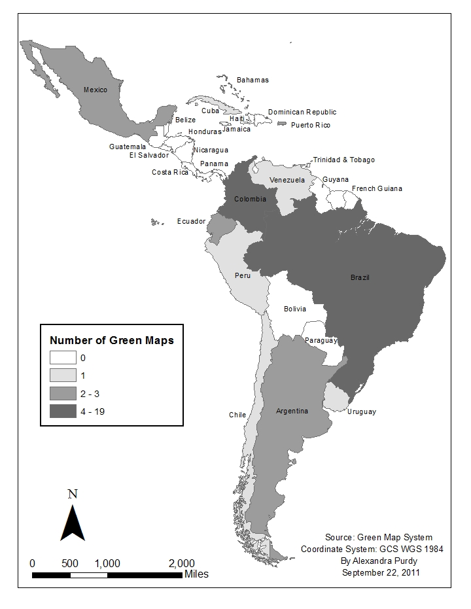

Colombia and Brazil have the highest number of registered Green Maps, with 11 and 19 maps respectively. A number of countries do not have any registered Green Maps the regions having few or no maps include Central America the Caribbean, and the interior of South America.

TABLE-1 General Map Information

*Information gathered July 2011

Total Latin American Maps | 47
Total Latin American Published Maps | 30
Scale Range | 1:4000 to 1:17,250
Range of Publication Dates | 1998- June 2011

- FIGURE-2 Language Map Count

- 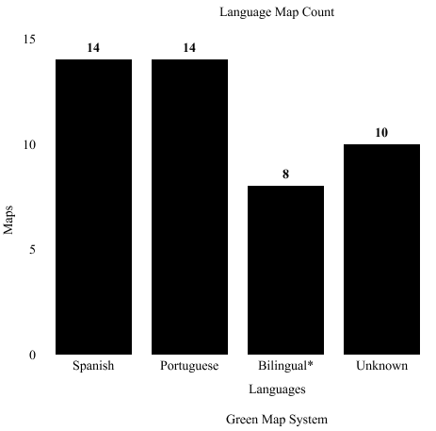
*Bilingual- English & National Language-
5 Spanish & English & 3 Portuguese & English

Maps were created in three languages, Spanish, Portuguese and English. Eight Latin American Green Maps used text in both their national language and English. In total, five projects were created in English and Spanish, and three projects were created in English and Portuguese. An equal amount of Portuguese and Spanish Green Maps have been created with both totaling 14 projects. Ten projects were unknown due to limited data.
- My first step in conducting research was to collect and document all existing Green Maps in Latin America. These were found through the Green Map System website, and as hard copies of maps in the Green Map Office archive room. Once all available map projects were located, I created a table listing each map’s location, title, if published, organization(s) involved, and name of mapmaker(s).
- My next stage of research was to categorize each map based on level of detail and completion. In order to classify each map, a ranking system was created.

Level 1: Incomplete project

A) Not published and no map information

Level 2: Underdeveloped project

A) Not published or published but not accessible

B) Or a map with 20 Green Map Icons or less

C) Or a project in progress within the last year

Level 3: Published Project

A) 21 plus Green Map Icons, icon descriptions

and map information.

Level 4: Well developed project

A) Has an updated or revised version

B) Complete project information on Green Map website

C) Comprehensive listing of green sites

This ranking system enables easier analysis of projects, as those ranked at level 1 or 2 are less developed and consequently has a limited ability to be sustainable. For analytical purposes however, sustainability needs to be defined and examined within a qualitative focus. Academics Bob Giddings, Bill Hopwood and Geoff O’Brien (2002) classify sustainability as the intersection between the environment, society and economy, which are conceived as separate although connected entities. The rationale behind breaking down sustainability into these three platforms lies in how together they cover the vital aspects of a community, its people and culture, vitality of business and profit, and maintaining the nature of a community. Authors Peter Rogers, Kazi Jalal and John Boyd (2008) agree with this mentioned definition of sustainability, they explain it, “meets the need for integrated decision making that is capable of balancing the economic and social needs of the people with the regenerative capacity of the natural environment” (Rogers et al. 2008). Green Map System defines sustainability in a similar way. In a personal interview, program director Wendy Brawer (2011) stated that sustainability is achieved through a balance of social equity, economic integrity and environmental vitality. Consequently, this study will use this definition to focus its analysis of Green Map Latin American projects.

Importantly, according to Wendy Brawer (2011) Green Map requires each project to be conducted in a participatory manner in order to qualify as socially equitable. Specifics of a participatory method are explained. This research assesses each of Green Map’s Latin American products as participatory using three criteria. First, a Green Map must ensure environmental vitality. The community’s environment according to Green Map relates to its “atmosphere,” or in other words, a combination of neighborhood green spaces and culturally significant locations. To be documented as having environmental vitality, this research requires a Green Map to reach a Level 3 or 4 in completion (noted above), meaning it is well developed, published, and includes all three green icon categories, culture, nature and green infrastructure on the map. Developments of businesses, organizations, networks, or use of land planning or governmental organizations for example, are possible positive results for a Green Map.

Second, the project must have a significant number of collaborators, at least 10 individuals and/or 2 group organizations involved. This confirms a collaborative group who are able to express their perspectives as mapmakers. Second, a project must facilitate discussion regarding the process and inclusion of green sites. This can be in the form of, conferences, group meetings, classroom activities, ect. This allows each individual to voice his or her opinion, for ideas to be challenged and compromises made. Lastly, a Green Map project must include participating mapmakers from the majority of neighborhoods or regions of the area being mapped. This will ensure the majority of mapped communities have a voice and are representative with this process.

Finally, for economic integrity each Green Map must have adequate funding to allow all desiring participants an ability to be involved, and to enable effective map distribution. Green Map believes well distributed maps best promote green businesses, and cultural and environmental sites within the community. Those qualifications to prove environmental vitality, documents a maps ability or inability to create change, and maintain cultural preservation and green spaces. The survey questions in combination with map analysis will determine the sustainability of Green Map projects, and ultimately whether or not Green Map System increases sustainability.
- The third stage of research was to contact and survey the green mapmakers or organizations in Latin America responsible for the registration of the Green Map project. To better reach out to these constituents, a survey was created. The survey was created using Google Survey and sent to all map project coordinators registered with a Latin American project. The survey provides greater detail on each Green Map project providing insight into who was involved, map accessibility, funding and project outcomes. The questions on the survey are in Appendix I.

Questions 2, 3, 4 and 5 determine participation, organization and volunteer involvement, and a project’s organizational methods. This subsequently assesses social equality, which is the first platform of sustainability. Questions 6 and 7 examine the second platform of sustainability, economic integrity. These two respectively determine how a map was distributed, funded, and potentially limited due to project funding. A Green Map has an ability to affect the economy as each map advertises and helps create awareness of the environmental green spaces, infrastructure or cultural sites within a community. Further, a Green Map project needs to be inclusive, and monetarily sound in order to be maintained and comprehensive. Question 8 extracts outcomes of each project, through a Green Map project’s ability or inability to generate greater outcomes; examples include new businesses, organizations, and building projects, generating community networks or a map influencing government policy. The last question, number 9, requests any additional information the mapmaker would like to give. These questions help determine whether or not a Green Map project was or was not participatory and/or sustainable.

The fourth task was to process and synthesize the data. The results would ultimately conclude whether or not Green Map projects are participatory, and whether or not they increase sustainability. Focus was first placed on each map’s participation methods. To determine participation, each project had to pass all three qualifications listed below.

FIGURE-3 Qualifications for Participatory Green Map Projects
Participatory Qualifications

1
Significant number of collaborators
* At least 10 individual participants or at least 2 partnering organizations.

2
Discussion of methods and mapping process
* Hosted meetings, or an interactive process where participants were able to share ideas.

3
Involved members from mapped neighborhoods/regions
*At least 60% of community neighborhoods/regions represented by a participating member

If all three questions were answered with a yes, then the Green Map project was determined participatory. If at least one question was answered with a no, then it was not considered participatory.
The next step was to analyze all results and data in relation to sustainability. Does each map increase sustainability in their respective region or city? To assess this, sustainability was considered according to three criteria, social, environmental and economic. A flow-chart diagramming the process of qualification is illustrated below.

FIGURE-4 Qualifications for a Sustainable Green Map
No: Not Sustainable
Yes: then…
ECONOMIC

1. Is the map accessible to the public, so as to best advertise green sites?
2. Money did not impede maintaining or developing the Green Map?

SOCIAL

1. Does the map fulfill all three categories to qualify as participatory?
(See FIGURE-3 above)
ENVIRONMENTAL
  - 1. Does the map fall within a Level 3 or Level 4 category?
  - 2. Are there icons listed from all three categories, sustainable living, nature, and society and culture so as to include all community Green Sites and land uses?
  - 3. Were there impacts generated within the community from their project?

No: Not Sustainable
Yes: ask…
No: Not Sustainable
Yes: ask…
Project fulfills all requirements of a sustainable Green Map.

Sustainable Qualifications

Considering these guidelines, each topic can be summarized into three questions: Are the mapping processes participatory as determined by the three qualifications defined in Fig. 3? Did the map project include icons from the three icon categories, be substantially developed, and generate outside projects, governmental use or community networks within the community? Is the Green Map accessible to the public in order to best promote each cultural, environmental or green infrastructure or business site on the map? Was money a limiting factor in the maintenance of the Green Map? If all questions within each category are answered with a yes, then the results present a qualitative example of a sustainable Green Map. If a question is answered with a no, then the Green Map does not represent a qualitative example of sustainability.

Results
Each Green Map in Latin America underwent an initial process of ranking and categorization regarding the completeness of each map, as well as the number and variety of the icons. Each was graded Level 1 through 4, where 1 is a non-completed project, and 4 is a well-developed project.
The results show 25 out of the 47 Latin American maps ranked level 4 (53%), 4 out of the 47 maps ranked Level 3 (8.5%), 8 out of the 47 maps ranked Level 2 (17%) and 10 out of the 47 maps ranked Level 1 (21%). As previously determined, those detailed and well enough developed to ensure environmental vitality, must qualify as either a Level 3 or 4. 62% of the Latin American Green Maps qualified under this guideline and 38% did not.
Further, results collected through map analysis and survey responses were organized within three sub-categories of sustainability: environmental, social and economic. The survey gathered data on the process and methods of each mapping project to understand their successes, setbacks, and ultimately to analyze Green Map's ability to increase sustainability in Latin America. The survey responses are translated and summarized, and consist of the information in the impacts, participants, data analysis, neighborhoods, map source and financial status columns. Map analysis was used to determine icon number, and icon variety. Successful map projects succeed all social, economic and environmental qualifications proving the projects ability to increase sustainability.
Over a course of 3 weeks, 21 mapmakers out of 47 responded to the Mapa Verde survey, which determined a 45% response rate, shown in Table 2.

TABLE-2 Number of Latin American Green Map Projects Responding to Survey

Total Projects | Projects That Responded
47 | 21

Out of those 21 projects, 9 qualified as a success (43%) and 12 were found unsuccessful (57%). Out of these unsuccessful maps, 33% were incomplete projects; those include Sorocaba, Brazil, Bogotá, Colombia, Yumbo, Colombia and Natal, Brazil. All successful projects are listed below.
Location of the successful and unsuccessful maps Green Maps in Latin America that responded to the survey are documented below.

TABLE-3 Country Statistics of Responsive Projects
Country | Successful | Unsuccessful
Brazil | 4 | 3
Colombia | 3 | 4
Mexico | 1 | 0
Puerto Rico | 1 | 1
Argentina | 0 | 3
Uruguay | 0 | 1
Total: | 9 | 12

Map projects in 6 out of the 12 countries responded. As a result, only 50% of Latin American countries with Green Map are represented in this analysis, however, these countries contain the bulk of Latin American Green Maps. Countries with no mapmaker responses, include, Chile, Cuba, Ecuador, Jamaica, Peru and Venezuela.
Concerning all map projects, five organization types, educational institutions, non-governmental, governmental, individuals, and community groups created Latin American Green Map projects. Each group structure was responsible for registering and supporting Green Maps in Latin America. Table 4 shows successful and unsuccessful organization types of the responsive Latin American projects.

TABLE-4 Organization Form Statistics of Responsive Projects
 | Successful Projects | Unsuccessful Projects
Educational Institution | 6 | 8
Non-Governmental | 2 | 1
Individuals | 1 | 4
Governmental | 0 | 1
Community Group | 0 | 3

An educational institution supported 66% of Mapa Verde projects. Successful education projects with Green Map ranged from larger universities, such as Unicamp in Brazil, to small local primary schools located in Pereira, Colombia. 22% were supported by a non-governmental organization, while individuals organized 11% of maps. No successful project was registered or supported by governmental organizations or community groups.
Out of the total unsuccessful maps, 66% were supported and created by educational institution, 33% by individuals, 25% by community groups, and 8% respectively by non-governmental organization, and governmental organizations. The only map project supported by a governmental organization was in Yumbo, Colombia. To better understand the success of organizations, Table 5 outlines the success rates of each. Non-governmental organizations had the highest success rate, where governmental organizations and community groups did not.

TABLE-5 Success Rate of Organizations
Organization | Success Rate
Educational Institution | 42%
Individuals | 20 %
Non-Governmental Organizations | 66%
Governmental Organization | 0%
Community Group | 0%

Map projects published their maps in various and often multiple ways. They ranged from interactive websites, murals, PDF’s, folding maps and posters. The average number of map products created per successful project was 2.5 where unsuccessful projects produced an average of 1.8 map products. All three successful schools in Pereira, Colombia succeeded in producing maps in all five forms.
Regarding data analysis, mapmakers used at least one or a combination of three methods to attain participation, gather data, and analyze and create their map projects. They did this by organizing group meetings, conferences and surveys.

TABLE-6 Data Analysis Methods
 | Successful Projects | Unsuccessful Projects
Group Meetings | 7 | 11
Conferences | 5 | 7
Surveys | 4 | 2

78% of successful projects conducted group meetings, 56% conducted conferences, and 44% conducted surveys to analyze their data. Comparatively, 92% of unsuccessful projects conducted group meetings, 58% conducted conferences, and 16% conducted surveys. Surveys had the highest success rate, while group meetings and conferences were nearly tied.

TABLE-7 Success Rates of Data Analysis Methods
 | Success Rate
Group Meetings | 39%
Conferences | 38%
Surveys | 66%

In regards to the area or regions each project mapped, 100% of projects determined successful mapped a single neighborhood, city center or school campus. On the other hand, 66% of projects determined unsuccessful mapped more than one region. This proves that projects mapping a single neighborhood are three times as likely to be successful, than those mapping multiple regions, neighborhoods or larger districts.
A variety of successful impacts resulted from these map projects. Those notable include, the Paraty, Brazil Green Map. Claudia Green, mapmaker of the project explained, “Green Map, Paraty has been presented around the world to Italy, Dubai. Ireland. Brazil. Greece, Zimbabwe and Tibet, and has helped the city receive UNESCO status.” Similarly, mapmaker, Maria Oliveira, creator of Mapa Verde do Bairro Cidade São Pedro explained how their city map provided inspiration for the creation of a community garden. Andre Baltimore, mapmaker of the San Miguel, Mexico Green Map described how their map was, “recently listed as an important community resource for the cities ‘green government’ funding.” These impacts demonstrate results that go beyond basic Green Map structures and processes, but stem from the process of Green Map creation.

Analysis
Critical to consider however, are the mapmaker response rates of Level 1-2 and 3-4 mapmakers. Results from the survey demonstrate mapmakers with Level 1 and 2 ranked maps had a 28% response rate, while mapmakers with Level 3 and 4 ranked maps had a 76% response rate. A potential explanation is that mapmakers with incomplete projects have less motivation to complete the survey knowing their project will not be analyzed as successful. Unreliable access to technology and global communication services is another possibility that limited responders and perhaps also made Green Map projects harder to realize successfully. Inactive Latin American projects, meaning those with no activity for more than 2 years, were included in map counts. Consequently, contact information could have been outdated. These survey response rates however, reflect a discrepancy, and should be taken into consideration when assessing the results.
Focusing on organization participation and involvement, educational institutions, non-governmental and individuals have been responsible for the creation of successful Latin American Green Maps. Success rates of each organization show those most and least likely to produce successful projects.
Two organization types, educational institutions and non-governmental organizations, have significantly higher success rates than the other options. Non-governmental organizations are most likely to produce complete and successful projects, where both governmental organizations and community groups are least likely. Potential explanations could be related to the level of organization, support systems, resources, and networks existing or established within each group. For instance, lack of success involving individuals, and community groups to create Green Maps could be because they have less access to funding, resources and existing participating members. On the other hand, educational institutions have access to free student labor and existing network organization, providing a possible explanation for their high levels of success.
Additionally, successful maps were more probable to have a higher average number of map forms accessible to the public, such as a mural, folded map, or an interactive website for example. While successful maps had on average 2.5 map formats of a given map, unsuccessful maps had an average of 1.8 map formats of a given map. Therefore, printing or publishing a map in an additional format proves advisable and able to increase a project’s success rate. Access to more funding, as well as greater organization and participation in most cases explain most projects’ ability to have higher publication rates. Similarly, once a map project proved successful, the organization or lenders would be more likely to provide funds for additional printing costs.
Projects using group meetings and conferences have similar success rates and are a more common methods of data analysis for Latin American Green Maps compared to that of surveys. Surveys include the production of a set of questions, related to the mapping area, that is either distributed through the internet, mail service or by hand. Interestingly, projects who conducted surveys were 25% more likely to succeed than those who did not. While surveys are more straightforward they are also more impersonal compared to group meetings or conferences. They are generally however able to gather larger and more specific quantities of data, as well as have a poll a greater number of people. Most beneficial however, would be to combine survey distribution and conduct group discussions, to enable efficient gathering of information, with a forum to discuss and analyze those results.
In regards to the boundaries, and specified regions of a mapping project, Latin American Green Maps range from mapping school buildings, campuses, neighborhoods, cities, and even countries (Puerto Rico). All Green Maps are required to state their spatial extent and can include a number of districts or municipalities on a single map. However, results demonstrate large-scale maps, those focused on a small area, were more likely to be successful: 100% of the successful Latin American Green Maps mapped a single area, such as a campus or neighborhood. All those who mapped 2 or more municipalities or neighborhoods proved to be unsuccessful projects. For the case of Latin American Green Maps, when concerning map extent, large-scale is better.
Respectively, the successful and unsuccessful projects have interesting trends, similarities and discrepancies. Comparisons of the environmental, social and economic results illuminate Latin American Green Map qualities and traits, and breaks down how Green Map influences its mapped regions. Further, these results reveal the most effective methods of producing Latin American Green Maps, while allowing direct documentation of the success and lack of success of each map. Statistically however, only 45% of the Latin American Green Map’s project sample proved sustainable. As this is less than half, the Green Map Latin American systems proves inefficient at producing sustainable maps, and consequently must be deemed unsuccessful. It is important to note however, that those project qualifying as successful proved comprehensive, as they were required to meet the three aspects of sustainability; economic, environmental and social.
Conclusion

A few recommendations are provided to Green Map projects in Latin America to enable the highest chance of their success. These project findings prove that a Green Map in Latin America will be most likely to achieve sustainability if it: is supported by a non-profit organization, has a mapping extent of a single neighborhood or school campus, is published in at least 2 formats, and uses surveys to collect and analyze data. If all guidelines are fulfilled then the map’s percent success rate will be 82%.
In Latin America however, access to resources and funding for community institutions or projects like that of Mapa Verde in Latin America, is a constant struggle. This issue consequently hampers Mapa Verde’s growth and production. In fact, survey results proved that additional projects would have resulted if funding had not inhibited organization and publication processes. For projects such as Mapa Verde de Montevideo and Aguas do São Pedro, for example, lack of funding limited their ability to print, distribute and publish their respective maps. Carlos Martinez, former Latin America Green Map Liaison and Director of Programs explained, “funding and lack of resources involving communication or Internet access is a consistent challenge for Latin American Green Maps. A recommendation to overcome this challenge is to support and promote the creation of murals as a form to publicize and display Mapa Verde Projects. Murals require materials such as paint, suitable surface areas, and significant donated time for creation. While other map forms require accesses to computers, printers and paper products, the materials required for murals are often more easily accessible to Latin American communities. Mapa Verde Cuba was the first Green Map to create a mural, and has utilized the technique effectively.

FIGURE-5 Mapa Verde Cuba Mural

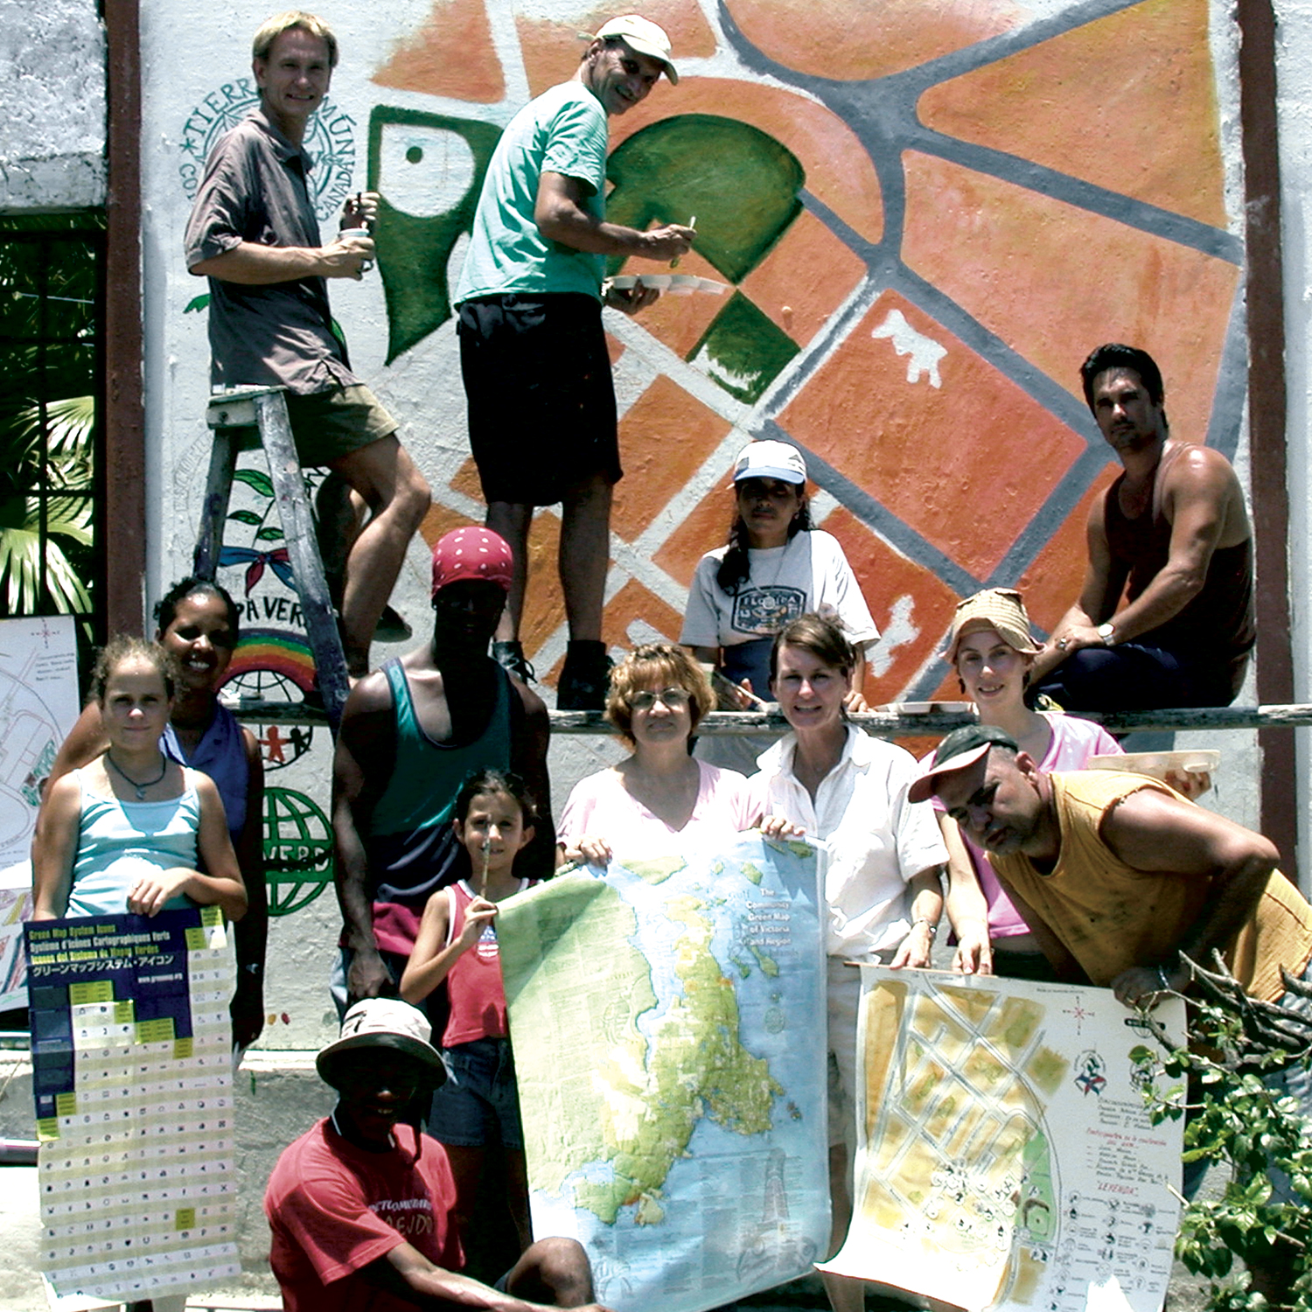
Mural Created by Mapa Verde Cuba

Green Map school projects in Pereira, Colombia have similarly developed mobile murals to publicize their maps. These large maps are painted on old pieces of wood, like that of plywood, making them light and easy to move throughout different parts of the school and into classrooms. Mural making, as developed in Cuba and Colombia can often be a more accessible and functional method to publicize maps in a community
Latin American Green Maps however constitute less than 10% of all Green Maps, published in the world. Fig. 6 below illustrates the locations of Green Map projects, and map counts per country. Unlike countries such as the United States, Canada, Japan and Indonesia, there are few Green Maps in Latin American countries.

FIGURE-6 Green Map Distribution Worldwide as of August 2005

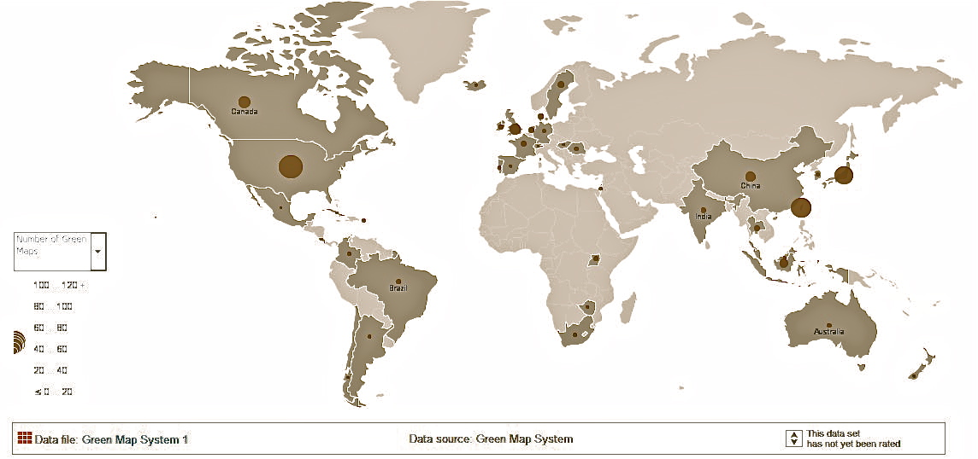

A struggle for Latin American Green Map projects is that an established network of Latin American mapmakers is not present. This decreases a Latin American mapmaker’s ability to collaborate with projects in their area. Similarly troublesome, Carlos Martinez (2011) discussed how, “the Green Map platform is not self-explanatory and is a difficult concept to grasp, especially for those not experienced with mapping concepts.” While guidelines for creating Green Maps exist in Spanish and Portuguese, there is a lack of supplemental translated materials and references for Latin American mapmakers. For Green Map System, focusing time on developing additional mapping resources in Spanish and Portuguese, as well as to create an easy to understand method to explain Green Mapping methods in all languages, would prove beneficial.
Ultimately, these project findings prove Green Map’s fundamental effectiveness to increase sustainability. After critical investigation of Latin American Green Map processes, impacts and results, nine maps have proven to fulfill all guidelines and requirements and consequently increase sustainability within its mapped region. Results illustrate that these Mapa Verde projects prove to have participatory mapping techniques, while succeeding to fulfill social, economic and environmental conditions. Those successful demonstrated community initiatives, such as movements to implement or enhance green infrastructure or community gardens. All successful projects promoted community discussion and reflection on the areas “green” elements. A number of Latin American Green Maps however did not meet the participatory, environmental, social and economic standards needed to increase sustainability. Unsuccessful projects however equaled 55% of the total project sample. These maps varied in completion, involvement and publication, but failed one or more qualification needed to prove sustainability. These findings verify that the Green Map Latin American platform is inefficient at producing sustainable map products. With greater development of Latin American Green Map resources however, and through a combined effort to promote the Mapa Verde platform by emphasizing the use of high success-rate methods and map qualities, Mapa Verde will experience a greater level of successful and sustainable initiatives.
While Green Map System encompasses multiple aspects of sustainability through its global platform, what are the costs of using this global framework? Are citizens losing their spatial culture from this system, and what are the detriments and benefits of the Green Map iconography? The development of a global iconography establishes a method to link locally created maps to a global network. Mapmakers however are compelled to use these symbols even if they do not relate to the demographics or culture of the mapped region. Take the icon Child Friendly Site, for instance, an image of a Caucasian child’s face with a baseball cap. Inherently, this icon represents a western-based image of youth, but must be used throughout all Green Maps globally. Another example is the icon for Landmark Dining/Pub; represented by a fork, spoon and glass bottle. While easily definable for most Western societies, map projects in Japan for instance, (one of the countries with largest number of Green Maps), must use this icon, despite its inconsistency with Japanese culture. The drawback of this iconography, as it imposes western culture upon a global demographic is a significant concern of this mapping method.
Through global symbology systems, geographer Susan Hanson (2002) writes, “Symbols have the potential to help us confront and ultimately reconcile conflicting models of the world. A map and its system of symbols is a simplification of reality that reflects a particular understanding of the world that can contribute to subsequent or competing models of reality.” Hanson illustrates the way map symbologies can directly influence “understandings of the world”. As in Green Map’s case, their icons similarly impose cultural expression, while influencing the way map-readers interpret the mapped culture. This example documents the cultural costs of mapping place and space to benefit local sustainability through a global framework.
It is important to note however, that while the Green Map System is flawed, it represents a unique field participatory mapping, linking local initiatives to a global scale. As this study proves, if Mapa Verde projects follow the structural and organizational recommendations proven to increase project success rates, the platform’s sustainable effectiveness will increase. If structured to facilitate operative organization, funding and participation, Mapa Verde in Latin America will evolve, improve and spread throughout the region. Proven beneficial impacts of the Green Map platform in Latin American solidifies its need, as well-developed projects will increase the region’s sustainability.

Work’s Cited

- Brawer, W. and Mulloth, B. 2010. Green Maps as a Vehicle for Social Change. Polytechnic University of New York. New York, NY.
- Brawer, W. Personal Interview. June 30th 2011
- Brodnig, G. and Mayer-Schönberger, V. 2000. Bridging the Gap: The Role of Spatial Information Technologies in the Integration of Traditional Environmental Knowledge and Western Science. The Electronic Journal on Information in Developing Countries. 1(1): 1-15
- Chapin, M. Lamb, Z. Threlkeld, B. 2005. Mapping Indigenous Lands. Annual Review of Anthropology. 34: 619-638.
- Crampton, J. W. 2009. Cartography: performative, participatory, political. Progress in Human Geography 33: 840-848.
- Dunn E. C. 2007. Participatory GIS- a people’s GIS?. Progress in Human Geography. 31: 616.
- Fahy, F. and Ó’Cinnéide, M. 2009. Re-constructing the urban landscape through community mapping: an attractive prospect for sustainability? Royal Geographical Society. 41(2): 167-175

Giddings, B. Hopwood, B. and O’Brien, G. 2002. Environment, Economy and Society: fitting them together into sustainable development. Sustainable Development. 10(4): 187-196
- Green Map System. 2011. Directions to a Sustainable Future. accessed: greenmap.org. Last accessed 29, July 2011.
- Hanson, Susan. 2001. 10 Geographic Ideas that Changed the World. New Brunswick NJ: Rutgers University Press
- Herlihy, H. Knapp, G. 2003. Maps of, by and for the Peoples of Latin America. Human Organization 62(4): 303
- Martinez, C. 2011. Former Latin American Liason and Director of Programs. Personal Communication. Date of interview 2, August 2011
- Meyer, JL; Helfman, GS. 1993. The Ecology Basis of Sustainability. Ecological Applications. 3(4): 569-571
- Nakagawa, K. Brawer, W. 2008. Green Map Impacts Reinvigorating communities around the world. Green Map System. [Greenmap.org] Last accessed 16 July 2011

Rogers, P. Jalal, K. and Boyd, J. 2008. An Introduction to Sustainable Development. London: Glen Educational Foundation.
- United Nations. 1987. Sustainability Definition. World Commission on Environment and Development. [un.org.en] Last accessed 3 September 2011
- Syahnaz, M. 2010. Iconography and Community Development- A visual methodical assessment of the role of Green Map Systems in fostering global citizenship. Malaysia: Green Map System.
- Tulloch, D.L. 2004. The green map system as a means for PPGIS education and exploration. Madison, WI. 3rd Annual Public Participation GIS Conference. [crssa.rutgers.edu/ppgis/PPGIS2004.pdf]

[http://crssa.rutgers.edu/ppgis/PPGIS2004.pdf ]
- Walsh, F. and Mitchell, P. 2002. Planning for Country: Cross-Cultural Approaches to Decision-Making on Aboriginal Lands. Jukurrpa Books. 4: 203-260.

Woodhouse, M. 2009. Citizen Science: Towards Global Environmental Sustainability. Saint Mary's University. 1(1): 1-20

Appendix

I

Survey for Latin American Mapmakers

- What was the name of your Green Map?

__________________________

- Who participated in creating your Green Map? Please check all that apply.

☐ University

-

☐ School group- (note grade)

-

☐ Individual community members

-

☐ Neighborhood club/group

-

☐ Non-profit organization

-

☐ Governmental organization

-

☐ Church group

-

☐ Other ____________

3) How many neighborhoods or regions are included on your map? Give the total number

_____________

4) How many neighborhoods (of the total listed above) are your participating mapmakers from? Give total number

_____________

5.) During your mapping process did you organize the following? Check all that apply.
- ☐ Group meetings
- ☐ Public surveys
- ☐ Conferences
- ☐ Other ________
- 6.) How can the public access your map? Check what form(s)?
- ☐ Folded map
- ☐ Poster
- ☐ Mural
- ☐ PDF
- ☐ Interactive website
- ☐ Other _____________

7) Describe the financial support and financial challenges of your project?

- 8.) How was your map a success or not? Were there sustainable or positive environmental impacts generated by this project? Please explain.

- 9) Do you have any additional stories, comments or observations you would like to share?

II

Images of Successful Green Maps in Latin America

FIGURE-7 Mapa Verde Montevideo, Uruguay
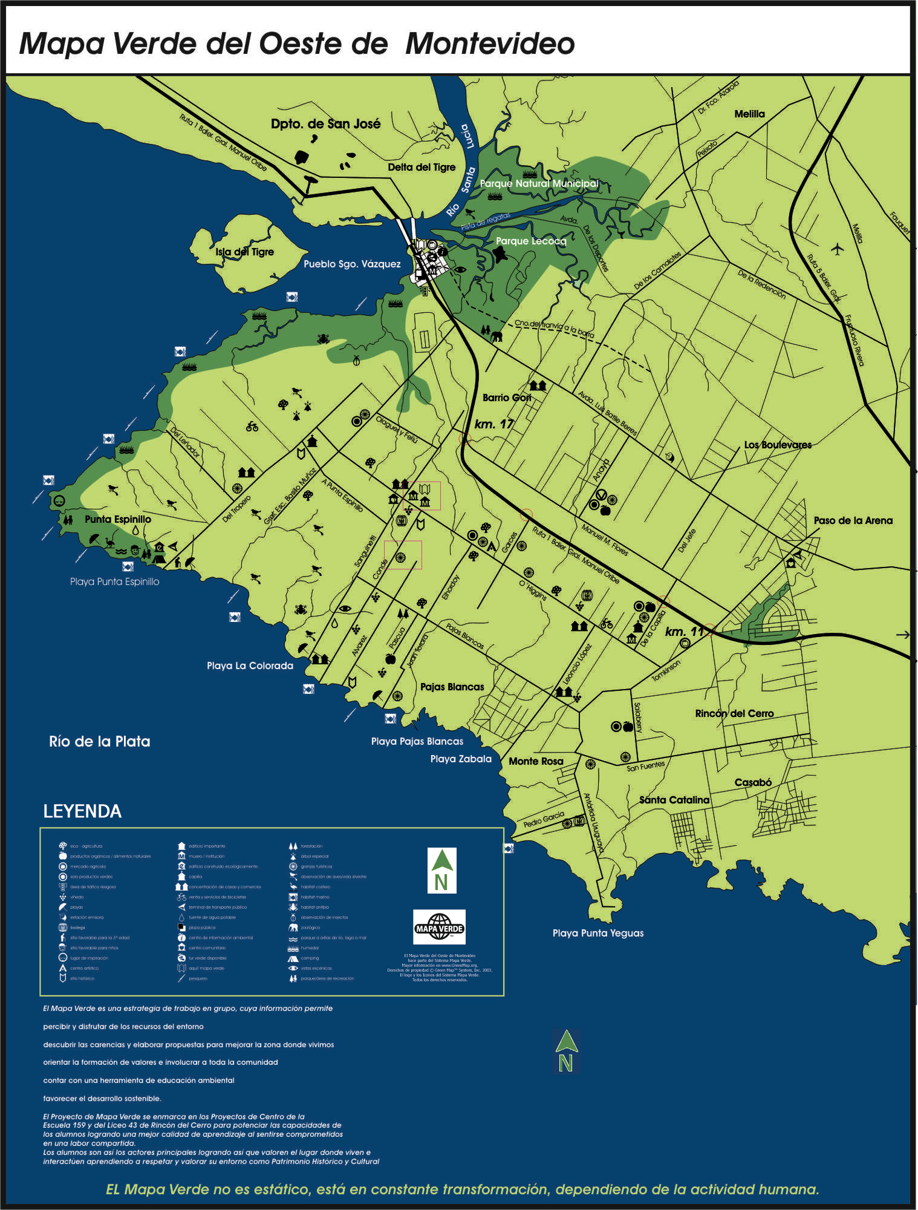

- Uruguay, Montevideo: Published Dec 2007

FIGURE-8 Mapa Verde Ecologico-San Juan
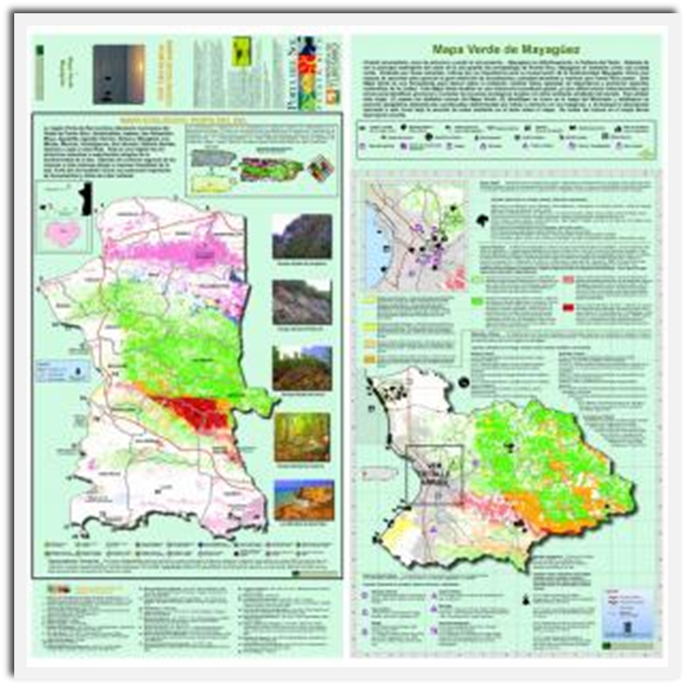

- Puerto Rico, San Juan: Published May 2007

- FIGURE-9 Mapa Verde Unicamp

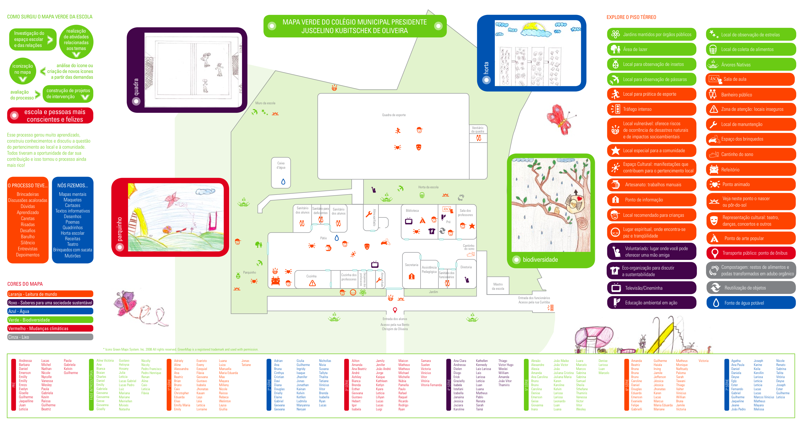

- Unicamp, Brazil: Published November 2009

V General Map Information

Name of known Latin American Green Map projects:
    - Mapa Verde San Miguel
    - Mapa Verde de la Ciudad de Mexico
    - Mapa Verde en Cuba
    - Mapa Verde Ecologico- San Juan, Puerto Rico
    - Mapa Verde Mayaguez, Puerto Rico
    - Mapa Verde Porta del Sol, Puerto Rico
    - Green Map Paraiso Costa Rica
    - Finca Salverde, Costa Rica
    - Quebrada La Vieja Bogóta, Colombia
    - Mapa Verde de Ecoourismo en Bicicleta, Colombia
    - Mapa Verde del Colegio, Colombia
    - Deogracias Cardona, Colombia
    - Barrio Boston, Colombia
    - Mapa Verde Barrio Hamburgo, Colombia
    - Mapa Verde del Colegio Suroriental, Colombia
    - Universidad Tecnológica de Pereira, Colombia
    - Mapa Verde del Instituto Gonzalo Mehia-Echeverri, Colombia
    - Quebrada Negra Quindio, Colombia
    - Zona Industrial- IZ, Colombia
    - Mapa Verde Portovelo, Ecuador
    - Bellavista Green Map, Ecuador
    - Mapa Verde de Wacarpay, Peru
    - Natura América do Sul, Brazil
    - Mapa Verde Palmas- TO, Brazil
    - Mapa Verde Natal, Brazil
    - Green Map Paraty, Brazil
    - Projecto Rio do Nosso Bairro, Brazil
    - Mapa Verde EMEF Adroniran Barbosa, Brazil
    - Mapa Verde São Paulo Dedo Verde na Escola, Brazil
    - Green Map of Cidade São Pedro Neighborhood, Brazil
    - Mapa Verde Sorocaba, Brazil
    - Mapa Verde Cabreúva, Brazil
    - Mapa Verde Campinas, Brazil
    - Mapa Verde da Unicamp, Brazil
    - Mapa Verde Piracicaba, Brazil
    - Araras Mapa Verde, Brazil
    - Águas de São Pedro, Brazil
    - Mapa Verde São Pedro, Brazil
    - Mapa Verde Ubatuba-Aoka, Brazil
    - UFPR- E-Campus, Brazil
    - Mapa Verde del Casco, Brazil
    - Santiago, La Chimba, Ñuñoa, Santiago Centro Mapa Verde, Chile
    - Mapa Verde de Oeste de Montevideo, Uruguay
    - Fundacional de La Plata, Argentina
    - Mapa Verde Buenos Aires, Argentina
    - Capilla del Monte Green Map, Argentina
    - Green Map of Valdez Venezuela

- Mapping Organizations: organizations responsible for the creation of a Green Map
    - Maps of San Miguel de Allende
    - Distrito Federal's Environmental Protection Acency
    - Procuraduria Federal de Proteccion al Ambiente con Secretario de Desarrollo Social
    - Projecto Mapa Verde Cordillera Alux
    - Centro Félix Varela
    - Fundacion SenderoVerde de Puerto Rico
    - University of Vermont
    - Finca Salverte
    - eRECICLAJE
    - Amigos de la Montaña
    - Fundación GeoVida
    - Paz Verde/Green Peace
    - Universidad Tecnológica de Pereira
    - Fundación GeoVida
    - Projecto Mapa Verde Yumbo
    - Saint Mary's University Citizen Science Project
    - Natura
    - EcoturismoBR
    - Federal University do Rio Grande do Norte- UFRN
    - Green Consensus
    - Ecosurfi
    - Mapa Verde Brasil
    - Governo do Estado de São Paulo
    - 5elementos
    - Instituto Brookfield
    - Mapa Verdep Socraba
    - Caminho das Águas
    - Mapa Verde de Campinas
    - Instituto de Cooperação e Desenvolvimento Ambiente Total Instituto Ambiente Total
    - Senac Sao Paulo
    - São Pedro Town Hall Prefeirtura Municipal da Estancia de São Padro
    - Departamento de Cîencia e Gestão da Informação
    - Ciudad Viva and Ecobarrio
    - Universidad de Flores

